Departures From Ketchikan
From: | FLT # | Depart | Arrive
Coffman Cove | FLT #
Tuesday & Thursday | 54 | 15:00 | 15:45
Saturday | 50 | 7:30 | 8:15
Craig | FLT #
Monday - Saturday | 70 | Call to book
Monday - Saturday | 72 | Call to book
Kassan & Meyers Chuck | FLT #
Flag Stop | 61-31 | Call to Book
Edna Bay | FLT #
Tuesday & Thursday | 54 | 15:00 | 16:00
Saturday | 52 | 7:30 | 8:35
Hollis | FLT #
Monday - Saturday | 70 |  | Call to book
Monday - Saturday | 72 |  | Call to book
Hydaburg | FLT #
Mon, Wed, Fri | 92 | 15:00 | 15:40
Metlakatla | FLT #
Monday – Sunday | 18 | 7:30 | 7:42
Mon - Wed, Fri, Sun | 108 | 11:30 | 11:42
Tues, Thurs, Sat  Monday-Sunday | 116  118 | 9:30  14:30 | 9:42  14:42
Monday – Sunday | 120 | 17:00 | 17:12
Nakauti | FLT #
Tuesday  Saturday | 52  52 | 15:00  7:30 | 16:15  8:45
Point Baker | FLT #
Tuesday  Saturday | 56  58 | 15:00  7:30 | 16:00  8:30
Port Protection | FLT #
Tuesday  Saturday | 56  58 | 15:00  7:30 | 16:15  8:45
Thorne Bay | FLT #
Monday - Saturday | 70 | 7:30 | 7:55
Monday - Saturday | 72 | 17:00 | 17:25
Whale Pass | FLT #
Tuesday  Saturday | 50  50 | 15:00  7:30 | 16:15  8:45
Departures to Ketchikan
From: | FLT # | Depart | Arrive
Coffman Cove | FLT #
Tuesday & Thursday | 51 | 16:00 | 17:45
Saturday | 55 | 8:25 | 10:00
Craig | FLT #
Monday - Saturday | 71 | Call to Book
Monday - Saturday | 73 | Call to Book
Kassan & Meyers Chuck | FLT #
Flag Stop | 62-32 | Call to Book
Edna Bay | FLT #
Tuesday & Thursday | 55 | 16:15 | 17:30
Saturday | 54 | 8:45 | 10:00
Hollis | FLT #
Monday - Saturday | 71 |  | Call to book
Monday - Saturday | 73 |  | Call to book
Hydaburg | FLT #
Mon, Wed, Fri | 93 | 15:50 | 16:30
Metlakatla | FLT #
Monday – Sunday | 19 | 7:48 | 8:00
Mon-Wed, Fri, Sun | 109 | 11:48 | 12:00
Tues, Thurs, Sat  Monday - Sunday | 117  119 | 9:48  14:48 | 10:00  15:00
Monday – Sunday | 121 | 17:18 | 17:30
Nakauti | FLT #
Tuesday  Saturday | 53  53 | 16:25  8:55 | 17:30  9:30
Point Baker | FLT #
Tuesday  Saturday | 57  59 | 16:10  8:40 | 17:30  10:00
Port Protection | FLT #
Tuesday  Saturday | 57  59 | 16:30  9:00 | 17:30  10:00
Thorne Bay | FLT #
Monday - Saturday | 71 | 8:05 | 9:00
Monday - Saturday | 73 | 17:35 | 18:00
Whale Pass | FLT #
Tuesday  Saturday | 51  51 | 16:25  8:55 | 17:30  9:30

Scheduled flights do not operate during the following holidays:

- May 25th
- November 11th
- July 4th
- September 7th
- November 26th
- December 25th
Thank you for your understanding!
WEB SPECIALS AVAILABLE ONLINE
www.taquanair.com

All Flights are weather
dependent and jet
connections are not
guaranteed.

Please note these are Bush Flights.
Route and Times are subject to change.

Current Schedule Effective:

May 11th, 2026 – September 13th, 2026
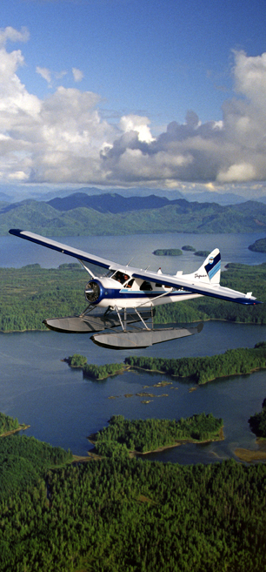


Ketchikan’s
Air Carrier
Summer Flight Schedule
Effective
May 11th – September 13th 2026

Phone: 907-225-8800



An Affiliate of:
For More Information
www.Kawanti.com
Info@Kawanti.com
907-225-8400

